OBJECT ORIENTED PROGRAMMING

Lab Assignment…

**Submitted by:**

**Name:** Md. Shakibul Islam

**ID:** CSE 07808427

**Date:** 5.5.2023

**Ahmed Abdal Shafi Rasel**

Senior Lecturer,

Department of CSE,

Stamford University Bangladesh

***Submitted to:***

#include <iostream>

using namespace std;

class Box

{

    int length;

    int breadth;

    int height;

public:

    Box() : length(1), breadth(1), height(1) {}

    Box(int l, int b, int h) : length(l), breadth(b), height(h) {}

    Box(const Box& B) : length(B.length), breadth(B.breadth), height(B.height) {}

    int getLength() const

    {

        return length;

    }

    int getBreadth() const

    {

        return breadth;

    }

    int getHeight() const

    {

        return height;

    }

    long long CalculateVolume() const

    {

        return (long long) length * breadth * height;

    }

    bool operator<(const Box& B) const

    {

        if (length < B.length)

        {

            return true;

        }

        else if (length == B.length && breadth < B.breadth)

        {

            return true;

        }

        else if (length == B.length && breadth == B.breadth && height < B.height)

        {

            return true;

        }

        else

        {

            return false;

        }

    }

    friend ostream& operator<<(ostream& output, const Box& B)

    {

        output << B.length << " " << B.breadth << " " << B.height;

        return output;

    }

};

int main()

{

    Box box1;

    Box box2(3, 4, 5);

    Box box3(box2);

    cout << "Box 1: " << box1 << endl<< "Box 2: " << box2 << endl<< "Box 3: " << box3 << endl;

    if (box1 < box2)

    {

        cout << "Box 1 is smaller than Box 2" << endl;

    }

    else

    {

        cout << "Box 1 is greater than or equal to Box 2" << endl;

    }

    if (box2 < box3)

    {

        cout << "Box 2 is smaller than Box 3" << endl;

    }

    else

    {

        cout << "Box 2 is greater than or equal to Box 3" << endl;

    }

    cout << "Volume of Box 1: " << box1.CalculateVolume() << endl<< "Volume of Box 2: " << box2.CalculateVolume() << endl<< "Volume of Box 3: " << box3.CalculateVolume() << endl;

    return 0;

}

***Output***

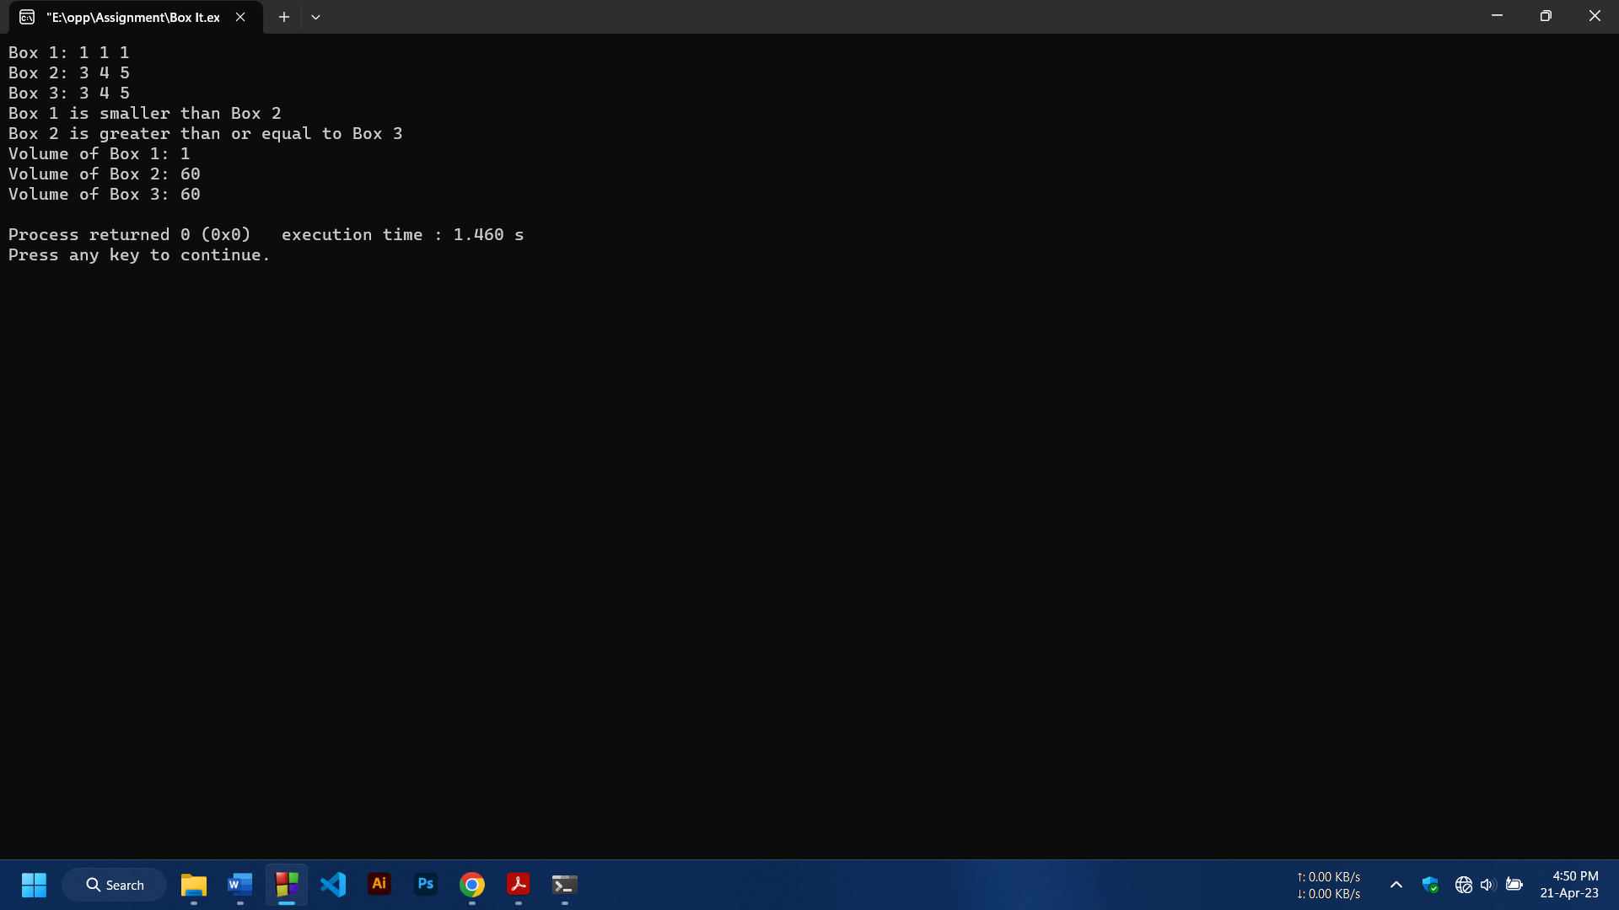

**-End-**